Numbers 31 Judgment and Warfare

This is a difficult passage not because of the account but because it seems to challenge our sense of justice and the present cultural view on these massacre. For theologians, the difficulties are deeper because this is but one example where it may appear that the God of the Old Testament is different from the God of the New Testament in the light of the teaching of Jesus Christ. We will look at these issues at the end of the study when we go into excurses and summary. For the group, we want to do a first level study to understand the text as it is written.

The instruction for battle (verses 1-6)

What is chapter 31 primarily about? What is the reason (or reasons) for the action that is being prepared and taken?

Who is the initiator of the battle?

Can you identify the main crime (or crimes) indicted against the Midianites?

Why are these crimes serious? What impact would they have on the Israelites?

Come back to modern day Singapore, shalom church in 2016, who would you reckon to be our real enemy (enemies)? What do you think our enemies are perpetrating against the believers and what is the consequences if they are successful?

Can you list the battle order? How many people are involved? Place that number side by side with the able men who can fight (Numbers 26:51) what would be your comments to this “army”?

Who is to lead the fight? Look at verse 6 and comment on the significance of what is being mentioned. (Phinehas as the leader, the use of the trumpet, the holy articles)

The report of the victory (verse 7 – 12)

Can you summarize a brief report on the outcome of the battle:

Verse 8 is significant as it actually named the chieftains who were against God’s people. Check out the following references and note your observations:

Joshua 13:21

Numbers 25:15

Numbers 24:14

What is your observation of verse 9-11 in the light of Deuteronomy 20:10-15? Did they do correctly according to the protocol of the day?

Follow up from the battle (verse 13-18)

If the soldiers had done correctly, why was Moses angry (be specific according to what was said in verse 15)?

Did you expect this reaction from Moses? What is the justification for the anger of Moses? Is it sinful or is it righteous?

For the actions of war for the Israelites, there are generally two treatments commanded:
For those conquest outside the promised land (see Deuteronomy 20:13-14)

And

For those conquest within the promised land (see Deuteronomy 20:16-18)

Can you highlight the differences?

Which one was applied for this case in Midian? Can you suggest a reason why?

Purification is needed (verse 19-24)

What did the soldiers have to do (can you name the process, from which chapter of Numbers is the provision given)? Why?

How are the spoils of war to be enjoyed? What steps are prescribed? Can you think of some New Testament passages that points to this action here in Numbers 31:19-24 as an illustration and spiritual lessons for us?

Dividing the Spoils (verse 25-47)

Give the division of the spoils (plunder) in the diagram below:
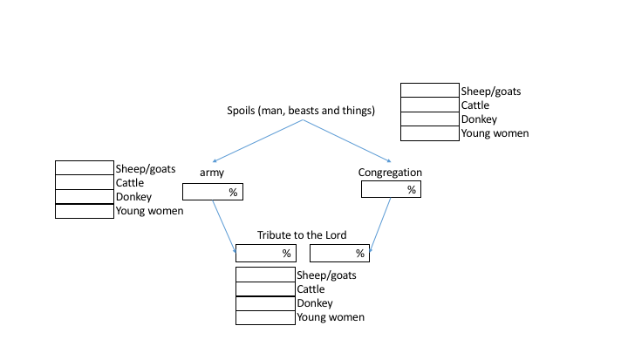

Who (on a per-capita basis) gets the most of the spoils? Why?

Why do the congregation get to share in the spoils? What is the lesson for us?

Why is there a need to give to the Lord? Why do you think there is a difference between what the soldiers gave and what the congregation gave?

Thanksgiving offering (verse 48 – 54)

Now there was an additional information on the report of the war, what is it (verse 49)?

Do you consider this report striking? How would you account for it?

In response to this report, what did the solders do?

Summary

Consider the whole cycle of events given in this chapter (war, report, celebrating the victory by dividing the spoils [cross reference to Isaiah 9:3], tribute to the Lord, thanksgiving offering), what can you learn from this passage?

